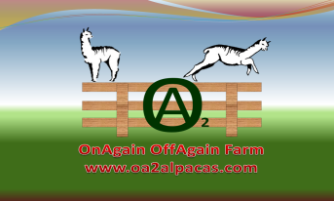

PacaPal Program Registration Form
- Thank you for choosing to sponsor a PacaPal.
The person who will be the adoptive ‘parent’ is the Sponsor.
If you are the person who will be the sponsor, please mark No in the gift question and skip down to Sponsor’s Name (your name) and complete the rest of the form.
If this as a gift, answer the gift questions. Then put YOUR name, email address and phone number where it is asked. and let us know where to mail the Welcome Package. Fill out the name and personal information about your recipient in the SPONSOR sections. We need to be able to contact both you and the person to whom you are gifting this PacaPal.
If you have a question, please include it in the appropriate field below.

- Please fill out the next four questions if you are giving a PacaPal sponsorship as a gift.
- Name of person giving the gift:

- Email address of person giving the gift:

- Phone Number of person giving the gift:

- If this is a gift, where do you want the Welcome Package mailed?

- Please completely fill out each field below to avoid delay in processing of your PacaPal registration.
- Sponsor's Name: *
Sponsor's Birth Date: *

- Parent or Guardian’s Name (if sponsor is under 18 years of age):

- Sponsor's Full Mailing Address *
Street Address

Street Address Line 2

City

State/Province

Postal / Zip Code
- Sponsor's Telephone Number:

- Sponsor's Email Address (or parent or guardian if a child): *

- Name of Alpaca to be Sponsored: *

- Questions, comments, special requests (please include contact info in case we need to reply to you)

- I agree to pay the $50 fee *
Signature:
- I have read and understand the PacaPal Program Description
- Date *

- Signature*

Disclaimer:
Your contribution of $50 is used toward covering the costs of daily care for your PacaPal and is non-refundable. Your payment of support does not constitute ownership of the animal but only entitles you to the benefits as listed in the Program Description. Sponsorships are not exclusive to one individual per alpaca. Others can sponsor this alpaca too. The sponsorship will last for 12 months at which time you can renew for another year or pick a new alpaca.

