MAA BOARD MEETING AGENDA
January 6, 2019
Judy Mullins’ Farm - Phippsburg

Attendees:

Anne Gobes, Judy Mullins, Ginny Rebar, Mike O’Brien, Marilyn Plowman, Tim Whalen and Kate Whalen

Agenda Topics:

- Membership dues accounting for 2018-2019
  - We have 30 Member Farms, 28 of them are on Open Herd; the other two choose not to advertise there.
  - Marilyn just received an application for membership from Gary & Trish Martin of Maple Crest Farm in Hermon, ME.
  - What can we do as an organization to bring in more membership? The discussion centered on adding 2 additional levels of membership; Associate and Youth. Our current level will be called, “Professional”. The level fees will be: $50, $35 and $10. Also, indicating on the website what each level of membership would provide.
  - Anne will draft up the listing of the levels and the benefits available for each of those levels.
  - Ginny made a motion to bring this discussion to the Annual meeting. Upon review of the By-Laws, we do not need to have a full membership vote to make the change in membership levels.
- Budget 2019: The Board members reviewed the budget and listed items for 2019. Marilyn will write up the budget proposal for presentation and vote at the Annual Meeting on January 27th.
- January Annual Member Meeting – January 27, 2019 – Location TBD
  - Board positions up for re-election – three
  - Board Nominations should be sent to Melissa Worrell
    - Anne and Marilyn terms end. Judy resigns due to family issues:
      - Both Anne and Marilyn agree to continue to serve and Judy will serve until someone else from the membership runs for the position.
- Anne was contacted recently by Lennie Foss, President of New England Alpaca Owners and Breeders Association (NEAOBA). He queried whether the Maine Alpaca Association would be interested in merging with NEAOBA. Anne brought this discussion to the board members. We were all in agreement that we wanted to remain a separate entity. If he was talking about us being a subsidiary of NEAOBA it might be different but MAA has worked hard to establish its presence in ME and we do not want to become invisible in a large organization. Anne has not heard anything further from Lennie.
- Planning the March 2019 Sorting Seminar: Presenter - Cheryl Gehley.
  - Charge the Professional members $75, $150 for non-members and Associate members. Nonmembers may opt to join MAA and receive a discounted fee at $125 for the workshop.
  - Reviewed the data from the questionnaire Anne sent out. Anne reported that 12 members responded – 10/12 members are interested in attending the workshop. Melissa Worrell mentioned she would be bringing some new farmers who just bought alpacas from them. She has not filled out the survey yet, but is interested.
  - The date for the workshop is March 2nd with March 9th as a snow date.
  - Anne will check on available venues: the Maine Farm Bureau, The Grey and Augusta American Legion Halls and anywhere else she can determine might be suitable.
  - Kate will write up a contract for Cheryl Gehley. Cheryl requires 50% deposit in advance of her fee and the remainder of the $1000 fee at the workshop. She will submit an invoice at a later date for her expenses. Marilyn will write the deposit check and give to Kate to forward to Cheryl.
  - Kate will send us a script to use for advertising for the workshop.
- 2019 Dates:
  - Maine AG Trade Show – January 14-17th
    - Mike will be there to setup on Tuesday and take down on Thursday. He plans on being there for the three days. Anne will take a time slot on Wednesday morning. Ginny prefers to host alone on Wednesday afternoon from 1:30-7, but would be willing to give up that slot if another member is interested in that time.
  - March AG Day at the Hall of Flags – Date to be Determined
  - June 1-2 Fiber Frolic – Submit application and check: Marilyn wrote the check and Anne filled out the application and will mail it. Gave copy Mike copy for set up.
  - July Maine 4-H Day Discussion: All Board members agreed to move forward with contacting Alisha Targonski from 4-H to be included in the event for Youth in July. Anne will contact Alisha.
    - Reviewed the information provided by Alisha at the November 2018 meeting.
      - Discussion – Working with alpacas and Youth - handouts were provided by Alisha via email to all members and hardcopies to Board members today.

- Need a Membership Campaign:
  - Discussion: Benefits

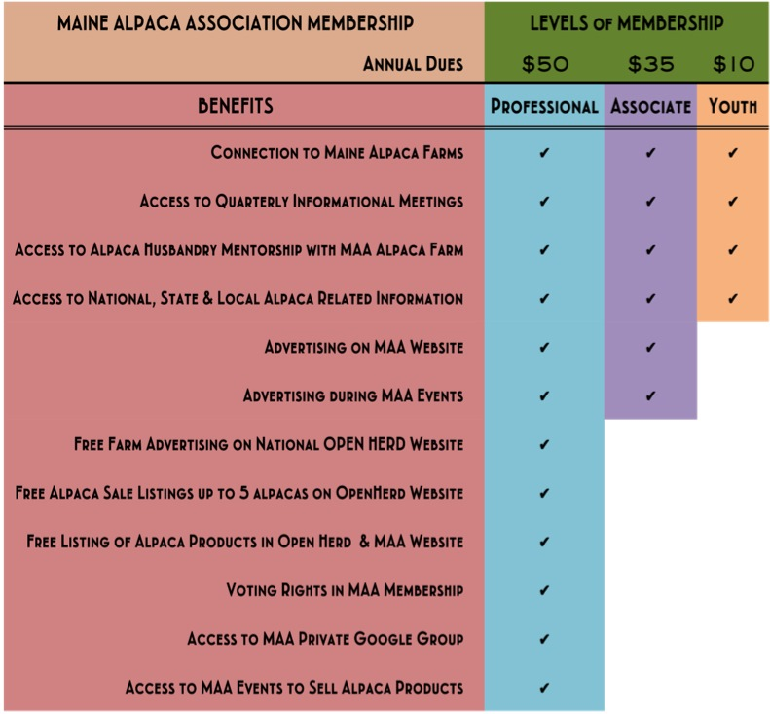
- Miscellaneous:
- Kate suggested that we update our old 3-fold brochure to have as handouts and Marilyn said she would work on that setup.

  - Judy mentioned that Wilbur’s Chocolate Confectioner’s can make alpaca chocolate pops at a cost of $1.25-1.50 per lollipop. All thought it was a good idea to use as a fundraiser. She will contact Andy Wilbur to determine if they can make 100 pops in time for the Maine Ag Trade Show January 14-17th.

