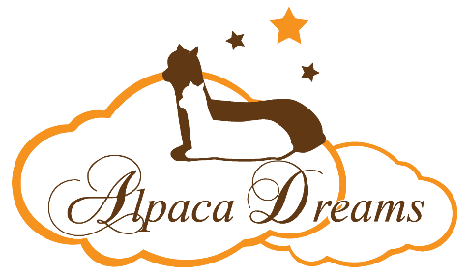
Animal Sponsorship Application Form
Please Print and Mail to the address at the bottom of the form.
Sponsor’s Name:______________________________________________________________
Sponsor’s Parent or Guardian’s Name (if applicable): _________________________________
Sponsor’s Address: _____________________________________________________________
Sponsor’s Phone: __________________ Sponsor’s Email: _____________________________
Sponsor’s Birthdate: _______________________
Sponsorship Level: $75 ____ $100 ____ $150 ____
Name of Alpaca to Sponsor: _____________________________________________
Is this a Gift? ____ If Yes, would you like copies of the Birthday Card and Quarterly Notes sent by the alpaca to the Sponsor? ______
What is the Gift Giver’s Name and Email (please print)? _________________________
____________________________________________________________________________
Disclaimer: Your sponsorship fee is used toward the costs of care for ‘your’ alpaca. Your payment entitles you to the listed benefits associated with the sponsorship level you have selected above and does not constitute ownership of the animal. The alpaca will remain at Alpaca Dreams, LLC’s farm. The sponsorship will last for 12 months. In the event your sponsored alpaca moves to a new farm or passes away, you will be able to choose a new animal for the remainder of the sponsorship term.
I have read and understand the Alpaca Sponsorship Program
Signature: _______________________________________________ Date: __________________________
____ A check for the sponsorship amount is included with this application.
Make check payable to Alpaca Dreams, LLC
____ Invoice me through PayPal. Send invoice to the following email address:
_____________________________________________________________________________
Complete this form and mail to:
Alpaca Dreams, LLC 2714 Schloss Rd., Louisburg, NC 27549

