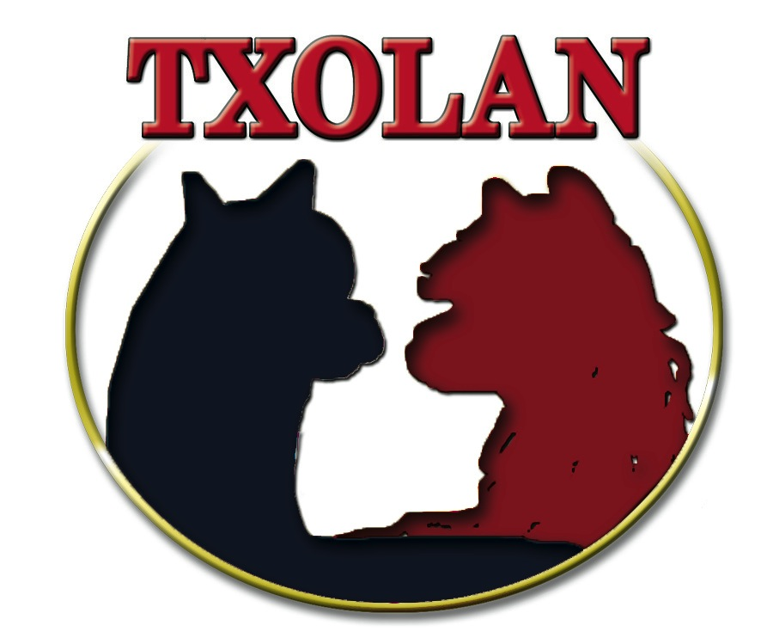

Application for Membership

Application for Membership
Name(s):
____________________________________________________________________________________________________
Ranch:
____________________________________________________________________________________________________
Address (physical):
______________________________________________________________________________________________________
Address (mailing):

Phone: _______________________________ Cell:_____________________________
Email: ________________________________________________________
Website: ______________________________________________________

Please e-mail your application to d.k.ashley@suddenlink.net or mail your application to:
Debbie Ashley
C/O Aubrey Oaks Alpacas
425 Woodbine Estates Road
Gainesville, TX 76240
(214) 734-1921

TXOLAN Alpaca Association Premier Membership Fee $120.00 annually
TXOLAN Alpaca Association Education Only Membership Fee $60.00 annually

Alpaca breeders who own alpacas and are interested in the future of the alpaca
industry are eligible for membership in the TXOLAN Alpaca Association, Inc.
All Premier members will be listed on the TXOLAN website, be eligible for all aspects of all events sponsored by TXOLAN and will be included in the “Find TXOLAN Ranches” page with a free Openherd account. This will also link to your website.

We invite you to get involved in TXOLAN.
Please let us know which committee(s) interests you.

____ Education/Seminars/4-H ____ Membership

____ TXOLAN Alpaca Spectacular Show ____ Communication/Marketing/PR

____ Board of Directors

