Alpaca Sponsorship Program
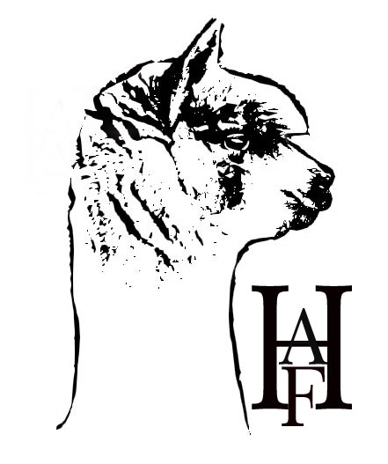at Hidden Alpaca Farm
Application Form
Sponsor’s Name: ________________________________________________________
Parent or Guardian’s Name (if applicable): ____________________________________________________
Name of Alpaca: ________________________________________________________
Is this a gift? : Yes __________ No__________
If yes, what is gift giver’s name: ____________________________________________
Address: ______________________________________________________________
______________________________________________________________________
Phone: _______________________________________
Email: ____________________________________________
Sponsor’s Birthday: ______________________________________________
Disclaimer: Your sponsorship entitles you to the benefits listed in the Alpaca Sponsorship Description and will be used toward the care for your selected alpaca. Your sponsorship does not constitute ownership of the animal and the selected alpaca will remain at Hidden Alpaca Farm. The sponsorship will be for one year (12 months), at which time you can select a new alpaca or renew the same alpaca for another year. In the event that your sponsored alpaca is sold, you will be able to choose a new one to finish out the sponsored year. Listed benefits may be changed or altered at anytime, without notice, to improve the sponsorship program.
I have read and understand the Alpaca Sponsorship Program Description.
Signature: ________________________________________ Date: ______________

Alpaca Sponsorship Description
Most everyone who meets an alpaca just falls in love with they’re cuteness and personalities. They would just love to take one or two home with them. Unfortunately, not all who fall in love with alpacas can do that as their home situation will not allow them that joy. Here at Hidden Alpaca Farm, for those who are denied the pleasure of owning an alpaca of their own, can help care for one through our sponsorship program.
Alpaca Sponsorship of an alpaca at Hidden Alpaca Farm is for one year (12 months) from the date of sponsorship payment:
- $125 Silver Sponsorship:
- Sponsor certificate with picture of “your*”alpaca
- Copy of “your* “ Alpaca registration papers (ARI)
- Felted Alpaca ornament from real Alpaca fiber

- $150 Bronze Sponsorship:
- Includes all benefits listed in the Silver Sponsorship
- Sample of “your*”Alpaca fiber
- Visits to the farm to learn handing and knowledge about “your*”Alpaca

- $175 Gold Sponsorship:
- Includes all benefits listed in the Bronze Sponsorship
- Invitation to shearing day at the farm
- Ownership of “your*” Alpacas’ prime blanket.
Your sponsorship entitles you to the stated listed benefits and will be used toward the care for your selected alpaca. Your sponsorship does not constitute ownership of the animal and the selected alpaca will remain at Hidden Alpaca Farm. This sponsorship will last for 12 months, at which time you can select a new alpaca or renew the same for another year. In the event that your sponsored alpaca is sold, you will be able to choose a new alpaca to finish out the sponsored year. Listed benefits may be changed or altered at anytime, without notice, to improve the sponsorship program. *”your”-refers to the alpaca you sponsored for the year.
Complete an Alpaca Sponsorship Form: Checks made payable to Carol E Haff Mail to: Hidden Alpaca Farm, 90 E Vargo Rd, Horseheads, NY 14845 Payment can also be made with a credit card in the Hidden Alpaca Farm Store.

